1. Anomalous temperature and non-injury mortality in the United States

Overview
[[[WORDS]]]

Introduction
- Deaths from cardiorespiratory disease have been associated with temperature
- However, hitherto no analysis by type of cardiorespiratory disease, by age group, sex

- No cancer association normally
- Other deaths also weird to look at but whatever

Data
I used vital registration data on all XX non-injury deaths in the contiguous United States from 1980 to 2016 along with population records to calculate monthly death rates for each type of cardiorespiratory disease as well as cancers and other deaths, age group, sex and state combination. In this analysis, I mapped each ICD-9 and ICD-10 code to two cardiovascular (ischaemic heart disease, cerebrovascular) and two respiratory (Chronic obstructive pulmonary disease (COPD), respiratory infections) types of cardiorespiratory deaths. The remainder were from a heterogeneous group of ‘other cardiovascular diseases’ and ‘other respiratory diseases’, within which the type of cardiorespiratory disease that led to death varied by sex and age group. I did not further subdivide cancer or other deaths. I obtained monthly population-weighted temperature from ERA-Interim. Full details of the data processing choices I made can be found in Chapter XX.
During 1980-2016, XX boys and men and XX girls and women died from cardiorespiratory diseases, accounting for XX% and XX% of all male and female deaths respectively. XX% of male cardiorespiratory disease deaths and XX% of female cardiorespiratory disease deaths were in those aged XX years and XX, and over XX (XX%) of male cardiorespiratory disease deaths were in those aged XX-XX years (Figure 1). In contrast with males, there was less of an age gradient in females after 15 years of age.
Deaths from XX, XX, XX, assault, and suicide accounted for 79.0% of cardiorespiratory disease deaths in males and 72.1% in females (Figure 1). XX was the leading cardiorespiratory disease cause of death in women younger than 75 years and men younger than 35 years. Between XX and XX years of age, more men died of XX than any other cardiorespiratory disease. Above 75 years of age, falls were the largest cause of death in both men and women.
There was a decline in age-standardised death rates of three out of XX major XX (XX, XX and XX) from 1980 to 2016, although assault deaths have shown a recent increase since 2014 (Figure 2). In contrast, age-standardised death rates from falls increased over time while those from suicide initially decreased followed by an increase to surpass 1980 levels. The largest overall decline over time was for transport deaths, which declined by over 50% from 1980 to 2016. Age-standardised death rates for XX and XX peaked in summer months but deaths from other major XX did not have clear seasonal patterns.


Figure 1. Number of cardiorespiratory disease deaths, by type of cardiovascular (ischaemic heart disease and cerebrovascular disease) and respiratory (COPD and respiratory infections) disease, by sex and age group in the contiguous United States for 1980-2016.

Figure 2. National age-standardised death rates from 1980 to 2016, by sex, cardiorespiratory disease and month

Statistical methods

National temperature model
I then analysed the association of monthly cardiorespiratory death rates with anomalous temperature using a Bayesian spatio-temporal model, described in Chapter XX. The model accounted for systematic variations in death rates across states and months, through state-, month- and state-month-specific random intercepts, and for their long-term trends. These terms together remove the effects of space and time varying factors other than temperature that affect injuries. Analyses were done separately by cardiorespiratory disease type, sex and age group. I used the resultant risk estimates and the age-sex-specific death rates from each cardiorespiratory disease type in 2016, to calculate additional deaths if each month in each state were +1°C above its long-term norm, by type of cardiorespiratory disease, sex, age group, state and month.

Subnational temperature model
I also attempted to run a model where each state was given a separate temperature anomaly coefficient (Equation XX in Chapter XX). However, the model would either not converge or not achieve sensible results without combining all cardiorespiratory diseases together. In Results, I present some results from this analysis.

Results
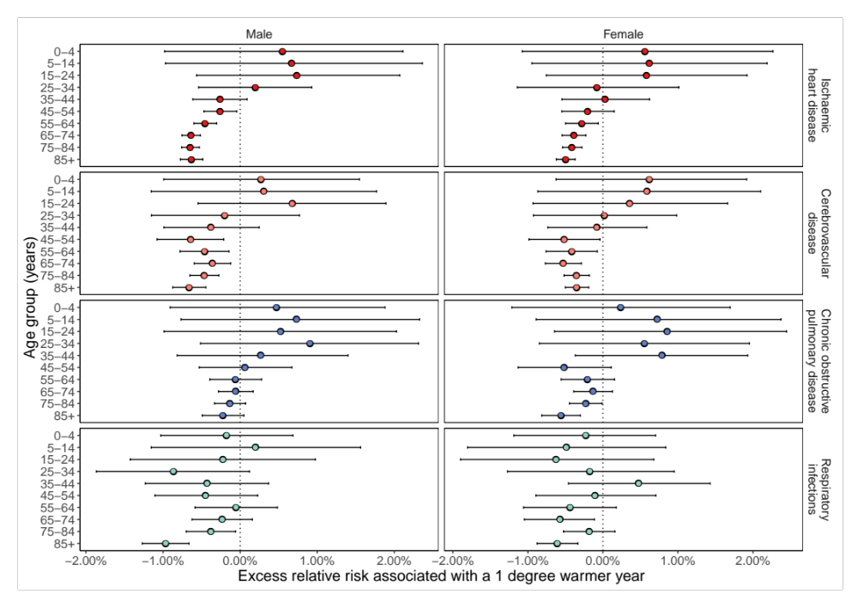
Figure 4. Percent change in death rates in year in which each month was +1°C compared with 1980-2009 norm temperatures by cardiorespiratory disease, sex and age group summarised across months.


Figure 5. Percent change in death rates in year in which each month was +1°C compared with 1980-2009 norm temperatures by cardiorespiratory disease, sex and month summarised across age.

Figure 6. Additional annual cardiorespiratory disease deaths for the 2016 US population in year in which each month was +1°C compared with 1980-2009 norm temperatures. The top row shows breakdown by type of cardiorespiratory disease, sex and age group. The bottom row shows the break down by cardiorespiratory disease, sex and month. Black dots represent net changes in deaths for each set of bars.

Discussion
[[[Words]]]

Figure 6. Percent change in ischaemic heart disease death rates in year in which each month was +1°C compared with 1980-2009 norm temperatures by month, sex and age group.

Figure 7. Percent change in cerebrovascular disease death rates in year in which each month was +1°C compared with 1980-2009 norm temperatures by month, sex and age group.

Figure 8. Percent change in COPD death rates in year in which each month was +1°C compared with 1980-2009 norm temperatures by month, sex and age group.

Figure 9. Percent change in respiratory infection death rates in year in which each month was +1°C compared with 1980-2009 norm temperatures by month, sex and age group.

Figure 10. Percent change in other cardiovascular disease death rates in year in which each month was +1°C compared with 1980-2009 norm temperatures by month, sex and age group.

Figure 11. Percent change in other respiratory disease death rates in year in which each month was +1°C compared with 1980-2009 norm temperatures by month, sex and age group.

Figure 11. Percent change in cancer death rates in year in which each month was +1°C compared with 1980-2009 norm temperatures by month, sex and age group.

Figure 11. Percent change in death rates from causes other than cancers, cardiorespiratory diseases and injuries in year in which each month was +1°C compared with 1980-2009 norm temperatures by month, sex and age group.

Works cited
Dee, D. P., Uppala, S. M., Simmons, A. J., Berrisford, P., Poli, P., Kobayashi, S., … Vitart, F. (2011). The ERA-Interim reanalysis: configuration and performance of the data assimilation system. Quarterly Journal of the Royal Meteorological Society, 137(656), 553–597. https://doi.org/10.1002/qj.828

